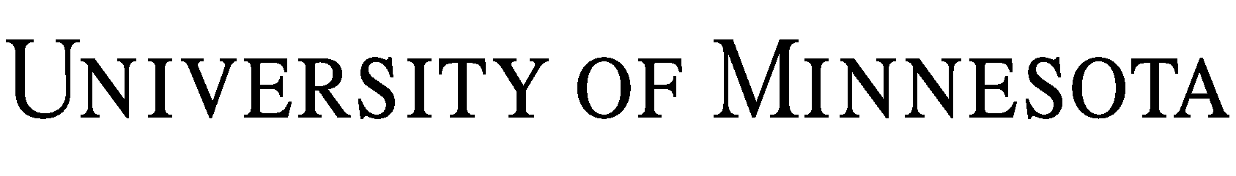
CONFIDENTIALITY AGREEMENT

THIS AGREEMENT is entered into effective as of , by and between Regents of the University of Minnesota (the “University”), a Minnesota constitutional corporation, and (the “Company”), a . This agreement is entered into by the University through its .

1. In connection with preliminary discussions that may or may not lead to agreements between Company and University for the University’s the performance of services, Company has agreed to provide the University with information relating to , which Company desires to be kept confidential. Additionally, the University may provide Company with information the University desires be kept confidential.

2. The parties hereby agree to keep the information each receives from the other confidential as outlined below.

3. Any and all information (“Confidential Information”) disclosed or submitted in writing or in other tangible form that is clearly and conspicuously labeled “CONFIDENTIAL” or “PROPRIETARY” shall not be disclosed to any third party. Confidential Information shall also include oral and visual disclosures, which are identified as confidential at the time of such disclosures and which are confirmed and summarized within fifteen (15) days of the disclosure by the disclosing party in a writing that sets forth the substance of the Confidential Information disclosed. Neither party shall use said Confidential Information for any purpose other than those purposes specified in this Agreement. The parties may disclose Confidential Information to employees requiring such access for the purposes of this Agreement provided, however, that prior to making any such disclosures each such employee shall be apprised of the duty and obligation to maintain Confidential Information in confidence and not to use such information for any purpose other than in accordance with the terms and conditions of this Agreement. Neither party shall be held financially liable for any inadvertent disclosure, but each will agree to use its reasonable efforts not to disclose any agreed-to Confidential Information. IN NO EVENT SHALL EITHER PARTY BE LIABLE TO THE OTHER PARTY FOR PUNITIVE, EXEMPLARY, INCIDENTAL, CONSEQUENTIAL, OR SPECIAL DAMAGES.

4. Nothing contained herein will in any way restrict or impair either party's right to use, disclose, or otherwise deal with any Confidential Information that at the time of its receipt:

4.1 Is generally available in the public domain, or thereafter becomes available to the public through no act of the receiving party;

4.2. Was independently known prior to its receipt, or made available to such receiving party as a matter of lawful right by a third party;

4.3. Is received without obligation of confidentiality from a third party who was free to disclose the information; or

4.4. Is required by law (including disclosures under the Minnesota Government Data Practices Act, Minnesota Statutes, Chapter 13), regulation, or court order to be disclosed. The University shall not be required to commence or defend any action to prohibit the inspection and copying of Confidential Information.

5. At any time, upon the request of the disclosing party, the receiving party promptly shall deliver to the disclosing party any property of the disclosing party, which may be in the receiving party's possession or control, including any and all documents and materials containing Confidential Information of the disclosing party (and all copies of the foregoing, except that the receiving party may retain one copy for archival purposes).

6. Expiration of Duty. Unless the parties agree otherwise in writing, the receiving party’s duty to protect disclosing party’s Confidential Information expires three years from the date of disclosure.

7. Export Controls:

The Company shall not convey technical data, technology, commodities, or software on the U.S. Munitions List, 22 C.F.R. pt. 121, or the Commerce Control List, 15 C.F.R. pt. 774, to the University without the prior written consent of the University’s Export Controls Officer (J. Patrick Briscoe, bris0022@umn.edu, 612-625-3860). The University may decline receipt of listed items at its sole discretion and at no penalty.

8. Each party hereto understands and acknowledges that any violation of this Agreement by it may cause the other party irreparable harm and damage, which may not be recovered at law, and agrees that the other party's remedies for breach hereof may be in equity by way of injunctive relief.

IN WITNESS WHEREOF, the parties have entered into this Agreement as of the date first above written.

Regents of the University of Minnesota

By: | By:
Name: | Name:
Title: | Title:
Date: | Date:

