Job Aid: Manage Delegations of Authority (Delegations)
Delegations of Authority System

Business Rules to Remember
- Delegated authorities are associated with positions; not people.
- When a position is vacant, the delegations remain associated with that position until a subsequent action is taken (e.g., transfer to a new position, remove a delegation).
- If delegations are tied to a position where there is more than one incumbent (multiple headcount), then all individuals with that position number will have those authorities. Positions with delegations should be limited to one incumbent where possible.
- A delegator must have an authority to be able to subdelegate to someone that reports to them.
- Delegators remain responsible for any authorities that they choose to subdelegate.
- Delegators may only delegate authorities to positions that report to them.
- Delegators may restrict further subdelegations of authority, but are not required to do so.

Viewing Delegations of Authority

Go to delegations.umn.edu.

Enter a value in one or more of the search fields. The more fields that are completed, the narrower the results will be.

Delegator (internet ID or position number)

If you do not know the internet ID for the individual you’re seeking, click on the question mark next to the Delegator label.

Delegatee (internet ID or position number)

If you do not know the internet ID for the individual you’re seeking, click on the question mark next to the Delegatee label.

Authority code (select from the drop down list or click on the question mark next to the Authority Code label)

University-wide, Campus, or College Code (select from the drop down list)

Department ID (optional)

Note: In the rare instance that the position number you’re entering is associated with more than one incumbent, all names associated with the position will appear. Multiple individuals sharing the same position will automatically have the same delegations.

Also, if the individual you’re seeking (internet ID), has delegations associated with two or more position numbers, the appropriate position number will appear on the delegation row.

View results.

The standard setting is to display 10 results. You may choose to display more rows by selecting a different number on the “Show Results” drop down located near the top left of the screen.

If you wish to further refine or sort the results, enter a keyword or phrase in the filter filter at the top right, or change the sort order by selecting the arrows to the left of the column label.

Print/export options

Print to printer or PDF

Export a CSV (comma- separated values) file to Excel.

Actions:
- Accessing Manage Delegations
- Add a New Delegatee
- Add a Delegation to a New Delegatee
- Add a New Delegation to an Existing Delegatee
- Update a Delegation of Authority
- Remove One or More Delegations
- Transfer One or More Delegations

Accessing Manage Delegations
- Go to delegations.umn.edu/admin.
- Log into the system with University internet-ID and password. (Note: The sign-in will time-out after three hours.)
- Select the 🔻 located to the right of your name.
- Choose manage Delegations from the options. The screen that appears is the starting point for the following actions: viewing delegations, adding or revising delegations, transferring and removing delegations.

Special Note

There are a few individuals in the system that have delegations associated with two or more positions that they hold. In those instances, the following will appear. Be sure to add, modify, transfer, or remove delegations from the appropriate position #.

Example:

Michael O'Connor
- 234851, 204382
- MOCONNOR
- BIOLOGICAL SCIENCES, COLL OF

This Delegatee has more than one position with delegations. Please click on the appropriate position number above to edit delegations

Add a New Delegatee
- Enter either the internet ID or position number of the individual who will be the delegator for the new delegatee, in the Delegatee field (on the home page for Manage Delegations). Click on Search or hit Enter on your keyboard.
- View the current delegations for the individual to determine which authority will be added to the new delegatee.
- Select the delegatee tab just under the individual’s name at the top.
- View the list of delegatees to ensure that the delegatee doesn’t already have one or more delegations.
- Once confirmed, click on the button labeled Add New Delegatee. The Add New Delegatee screen will appear.
- Select the new delegatee position number to add from the Delegatee drop-down list. You may select a vacant position or a position that has a current incumbent.
  - The positions in the drop-down list are “attached” to the delegator in the Human Resources Management System (HRMS) by the Reports To Field.
  - An individual may have more than one position. View the titles that are associated with the multiple position numbers to ensure that the correct position number is selected. If you select a position number that is shared with others, adding delegations to that position will automatically give the same authorities to the other individuals sharing that position number.
  - If the individual you are seeking does not appear in the list, then that association likely does not exist between this delegator and the position to be added.
  - Contact your Human Resources specialist to find out who the delegator for that new delegatee would be.
- Click on the Add Delegation button. The system will require that at least one delegation of authority be included in the initial setup, and an error message will appear if clicking on the Add button before adding one or more delegations.
Add a Delegation to New Delegatee
This screen will appear when adding a delegation.
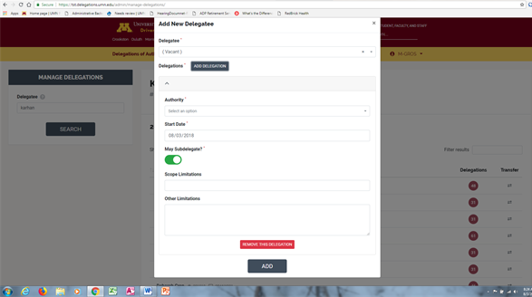
- The new delegatee you selected from the drop-down list should appear in the Delegatee field.
- Click on the 🔻 located to the right of the Authority field. This will display the authorities that the delegator has.
  - Note: If the delegator has an authority with a limitation of “May Not Subdelegate”, that authority will not appear on the list.
- Select the authority to add to the new delegatee.
- Select the College/Campus code from the drop down. (required)
  - Only allowable values will appear in the drop down.
- If the delegation will be limited to a particular DeptID, select the appropriate DeptID from the drop down on the Department field.
  - If the authority will be added for more than one DeptID, separate delegations must be created. This is accomplished by pressing your control key (hold) and selecting the desired Dept IDs under the Departmental field drop down.
- Allow the Start Date for this authority to default to the current date. Caution: Do not select a past date as this will cause unintended consequences. (Future dating capabilities are being planned but are not available at this time.)
- If the delegator of this authority wishes to place a restriction that this authority not be subdelegated further, slide the May Subdelegate button to the left (from green to gray). Otherwise, leave as is.
- The delegator may choose to assign a maximum amount or dollar limitation for the amount (e.g., up to $5000).
  - The system defaults to null or no stated dollar limitation.
  - If a limitation is needed, select a value from the drop down on the Dollar Limitation field.
- There are two remaining optional fields for setting up a new delegation: Scope Limitation and Other Limitation. Complete them if appropriate for this specific delegation.
  - These two fields are text only and no system edits are built off of the information entered in the fields.
  - Each field is limited to 250 characters. There is a character counter in the lower right hand corner of the field to assist you.
  - Scope Limitations: Use this field to specify a limitation in authority (e.g., excludes granting of leaves) or a limitation to the unit scope (only for Departments X and Y).
  - Other Limitations: Use this field to add more limitations or requirements associated with this delegation (e.g., requires approval by the Dept Chair for transactions greater than $50,000)
- If more than one delegation will be given to the new delegatee at this time, click on the Add Delegation button at the top and a new add form will appear.
- However, if only one delegation will be given at this time, then click on Add at the bottom of the form to complete the action.

Add a New Delegation to an Existing Delegatee
- Enter either the internet ID or position number of the individual to whom the new delegation will be added (on the home page for Manage Delegations)..
- View the current delegations for the individual to confirm that they currently do not have that authority for the unit specified..
- Click on the Add a New Delegation.
- Select the authority to add to the delegatee.
- Select the College/Campus code from the drop down (required).
  - Only allowable values will appear in the drop down.
- If the delegation will be limited to a particular DeptID, select the appropriate DeptID from the drop down on the Department field (optional).

  - If the authority will be added for more than one DeptID, separate delegations must be created. This is accomplished by pressing your control key (hold) and selecting the desired Dept IDs under the Departmental field drop down.
- Allow the date to default to today’s date. Caution: Entering a past date causes unintended consequences.
- If the delegator of this authority wishes to place a restriction that this authority not be subdelegated further, slide the May Subdelegate button to the left (the color will change from green to gray.) Otherwise, leave as is.
- The delegator may choose to assign a maximum amount or dollar limitation for the amount (e.g., up to $5000).
  - The system defaults to null or no stated dollar limitation.
  - If a limitation is needed, select a value from the drop down on the Dollar Limitation field.
- There are two remaining optional fields for setting up a new delegation: Scope Limitation and Other Limitation. Complete them if appropriate for this specific delegation.
  - These two fields are text only and no system edits are built off of the information entered in the fields.
  - Each field is limited to 250 characters. There is a character counter in the lower right hand corner of the field to assist you.
  - Scope Limitations: Use this field to specify a limitation in authority (e.g., excludes granting of leaves) or a limitation to the unit scope (only for Departments X and Y).
  - Other Limitations: Use this field to add more limitations or requirements associated with this delegation (e.g., requires approval by the Dept Chair for transactions greater than $50,000)
- Click Add at the bottom of the form to complete the action.

Update a Delegation of Authority
- Enter either the internet ID or position number of the individual for whom a delegation of authority will be updated (on the home page for Manage Delegations).
- Locate the delegation that is in need of modification.
- Click on the pencil icon located to the right of the specific delegation. This form will appear.
- The information from the original delegation will pre-populate the form.
- Revise the field(s) as specified by the delegator, such as change a Dollar Limit, add a new Scope Limitation, revise Other Limitations, etc. Caution: Allow the date to default to today. Selecting a past date causes unintended consequences.
- Once all changes have been made, click the Update button.

Remove One or More Delegations
- Enter either the internet ID or position number of the individual from whom one or more delegations will be removed.
- View the current delegations for the individual to confirm that they have the authority that is planned for removal.
- Click on the box to the far right of the delegation to be removed. A confirmation message which says “a delegation is selected for removal” will appear at the bottom of the screen.
- Click on the Remove button.
- The system will ask again if you’re sure you want to remove the delegation.
  - If a delegation is removed, even if in error, there is no way to reverse the action. The delegation(s) would need to be re-added to the delegatee.
- Click Remove.
  - If a subdelegation(s) from this position to another for this particular delegation exists, an error message will appear and the removal will not occur.
  - The subdelegation(s) would need to be removed first, before completing this delegation removal.
  - Once complete, the delegation should no longer appear for this delegatee.
- If all authorities for a position should be removed, select the box located just above the list of all delegations. Once selected, a check mark should appear in the boxes for all authorities.
  - The red message box that appears at the bottom of the form will specify how many delegations will be removed with this action.
  - If this is not how many delegations that should be removed, unselect the box located just above the list of all delegations (or click on the Clear All words located by the Remove button.
  - Then, select one or more individual delegations to remove.
- Click Remove.
  - If a subdelegation(s) from this position to another for one or more of these delegations exist, an error message will appear and the removal of that delegation will not occur.
  - The subdelegation(s) would need to be removed first, before completing this delegation removal.
  - Once complete, the selected delegations should no longer appear for this delegatee.

Transfer One or More Delegations
- Enter either the internet ID or position number of the delegator who has authorized a transfer of delegation(s) within their unit (on the home page for Manage Delegations).
- Select the delegatees tab located just under the delegator’s name.
- Find the individual/position from whom one or more delegations will be transferred.
- Click on the transfer icon located to the far right of the selected delegatee.
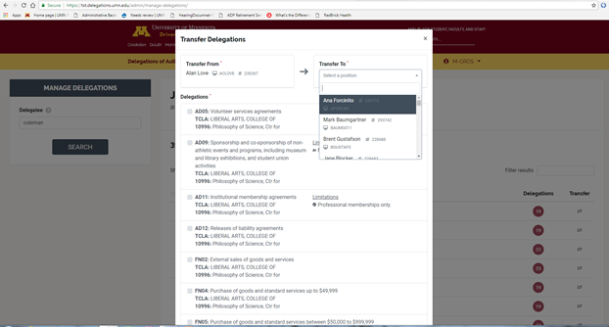
- The form of possible delegations will appear (see screenshot above).
- Review the delegation(s) to be transferred to ensure that the scope (unit) and limitations (e.g., dollar amount, scope) are what should be transferred to another position in the unit.
  - If a limitation will be different than what currently exists, complete the transfer first and then update the delegation as a second step.
- If yes, check the box in front of the selected delegation(s).
- Choose a Transfer To individual/position from the drop down list.
  - You may select a position that is vacant or one where there is an incumbent.
  - Positions in the drop-down list are “attached” to the delegator in the Human Resources Management System (HRMS) by the Reports To Field.
  - If the individual does not appear in the list, then that association likely does not exist between this delegator and the position to be added.
  - Contact your Human Resources specialist to find out who the delegator for that new delegatee would be.
- Click on the Transfer button.

