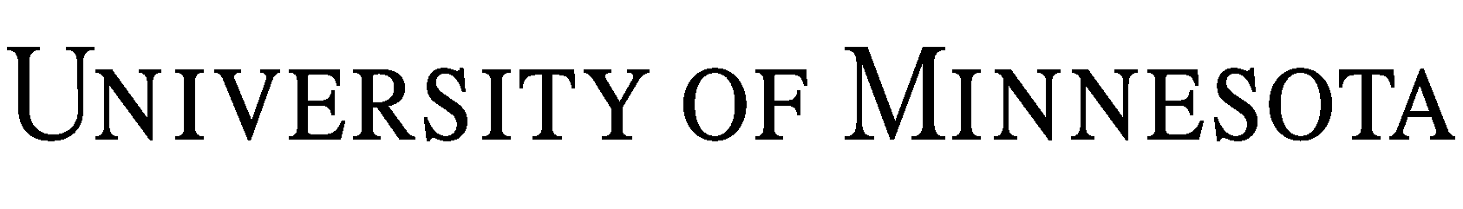
MEMORANDUM OF UNDERSTANDING (“MOU”)
Between
Regents of the University of Minnesota
on behalf of its
(“UMN”)
and
(“ ”).

UMN and , wishing to strengthen their academic and scholarly links and cooperation between faculty and students of both institutions agree as follows:

1. Purpose of the MOU. The purpose of this MOU is to establish cooperative academic relationships between the two institutions in areas discussed below.

2. Scope of the MOU. The parties agree to undertake good faith efforts and discussion with the goal of establishing academic and scholarly cooperative projects that are of mutual interest to colleges, departments and students of each institution.

3. General Areas of Cooperation.

3.1 Subject to the availability of funds and the written approval of the interested parties of both institutions, the institutions shall endeavor to develop plans which would include the following areas of cooperation.

3.1.1 Exchange of faculty members for agreed upon periods of time.
3.1.2 Organization of possible joint activities, including the exchange of scientist and technical staff members.
3.1.3 Organization of joint conferences or symposia.
3.1.4 Exchange of students.

3.2 Neither UMN nor shall discriminate on the basis of race, color, creed, religion, national origin, gender, age, marital status, disability, public assistance status, veteran status, sexual orientation, gender identity or gender expression in the performance of this MOU.

4. Financial Arrangements. Both institutions agree that all specific financial arrangements are to be negotiated separately for each component and are dependent on mutual interest and on the availability of funds.

5. Administration.

5.1 The terms and necessary budget for each program and activity that is implemented under the terms of this general MOU shall be mutually discussed and agreed upon in writing by both parties prior to the initiation of the particular program or activity. Such work protocols shall be negotiated on an annual basis.

5.2 Each institution will designate a contact person to develop and coordinate specific activities or programs.

6. Duration of the MOU. This MOU will be effective from the date of signature for an initial period of three (3) years. Thereafter, it will be renegotiated for three (3)-year periods, subject to revision or modification by mutual written agreement. Either party, by written notice to the other party no less than three (3) months prior to the end of any such year period, may terminate this MOU at the end of the current year period.

7. Use of Name or Logo. Neither party will use the name, logo, or other marks (including, but not limited to, colors and music) owned by or associated with the other or the name of any representative of the other in any sales promotion work or advertising, or any form of publicity, without the written permission from an authorized representative of the other.

IN WITNESS WHEREOF, each individual signing below hereby represents that they are duly authorized to execute and deliver this MOU on behalf of their respective party.

Regents of the University of Minnesota  Recommended for approval:  By:  Name:  Title:  Date: | By:  Name:  Title:  Date:
By:  Name:  Title:  Date: | By:  Name:  Title:  Date:
Approved:  By:  Name:  Title:  Date: | By:  Name:  Title:  Date:

