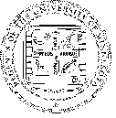
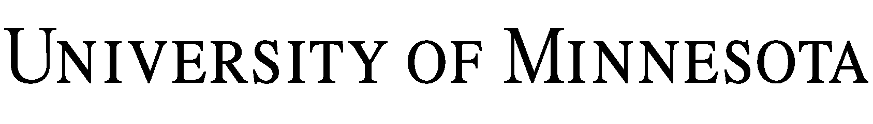
Activity Risk & Waiver Form
Minnesota English Language Program

I have been approved and wish to participate in Minnesota English Language Program (MELP) located on the University of Minnesota – Twin Cities campus. In consideration for the opportunity to participate in this program, I understand and agree that:

1. MELP hosts activities both on and off campus. I am aware that there is a risk of accidents or injuries during the following situations:

- Optional on and off campus social activities (e.g. surrounding businesses, public spaces). Some social activities are more physical/sporty in nature (e.g. snow tubing, ice skating, soccer)
- Required field trips for class (e.g. local museums, nursing homes, other attractions)
- My use of public or private transportation to attend social activities or field trips

2. I accept that some social activities or field trips may include the risk of injury, and I take full responsibility for these risks and will not hold the University of Minnesota or MELP responsible for any injuries to myself.

By signing below, I confirm that I have read and understand this Activity Risk & Waiver Form, which shall continue in effect for the duration of my program while I am studying at MELP. If there is information I do not understand, it is my responsibility to ask a MELP staff or faculty member for help (or contact MELP at esl@umn.edu).

Signed By:
Name:
Date:
MM DD YY

FOR PARENTS/GUARDIANS OF PARTICIPANTS OF MINORITY AGE
(UNDER AGE 18 AT TIME OF REGISTRATION)

I, as parent/guardian with legal responsibility for this participant, do agree to their release as provided above of the University of Minnesota, and, for myself, my heirs, assigns, and next of relatives, I release and agree to indemnify and hold harmless the University of Minnesota from any and all liabilities incident to my minor child’s involvement or participation in these programs as provided above, even if arising from the negligence of the University, to the fullest extent permitted by law.

Signed By:
Name:
Phone Number:
Date:

Risk is the possibility that something bad or unpleasant (such as an injury or a loss) will happen.

