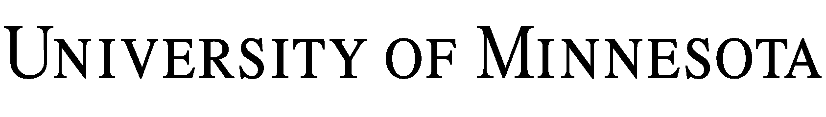

LAB USE ASSUMPTION OF RISK AND RELEASE OF LIABILITY
FOR VOLUNTEERS AND VISITORS

I request permission to participate in activities in laboratory/office facilities connected with the Department of at the University of Minnesota (the “University”) in connection with the following Activity:

Because I am not a University student or employee, I understand that I will not be covered by any health and/or accident insurance while I am volunteering or visiting these facilities. I anticipate being at the University facilities for the period to ; however, I understand that the University has made no commitment to make the laboratory/office facilities available for any specific time period and I will leave and remove my personal property when asked to do so.

I agree to review the applicable Laboratory Safety Plan prior to participating in any laboratory activity and to follow all rules and directions from University personnel regarding use of the facilities and equipment. I understand, appreciate, and acknowledge there is a risk of injury from using the University facilities and equipment, including the potential for serious injury and death. I voluntarily assume the risk of any injuries (regardless of severity) and death, which I may incur due to negligence or accidental occurrences while I am using University facilities and equipment. I agree that if I am personally injured or suffer any loss of or damage to personal property, I will not attempt to claim coverage under any University insurance policy. Further, in consideration of the opportunity to use University facilities and equipment, I, on behalf of myself, my agents, heirs and next of kin, hereby release the Regents of the University of Minnesota and its employees and agents and other volunteers from any responsibility or liability for personal injury, including death, and damage to or loss of personal property, that I may incur due to negligence or accidental occurrences while I am using University facilities and equipment. The foregoing shall not apply to injuries, death, damage, or loss that was caused by the intentional, willful, or wanton acts of the University.

I understand that, by participating in the Activity, I may be exposed to coronavirus or another communicable disease (“Disease”). By participating in the Activity, I assume the risk, that I may be exposed to and contract a Disease and, if that were to happen, that I may require hospitalization or other medical treatment and may be temporarily or permanently injured or disabled or may die. I also assume the risk that I could pass the Disease to others. I agree to take reasonable steps to lessen my and other participants’ risk of exposure to a Disease. By participating in the Activity, I warrant that, to my actual knowledge, myself and individuals living with me are not infected with a suspected, diagnosed, or confirmed case of a Disease and are not exhibiting symptoms of a Disease. I also warrant that I have not been directed to quarantine or isolate at any point during the duration of the Activity. If at any point during the duration of the Activity I am directed to quarantine or isolate, I will stay home, and I will not be entitled to compensation related to the Activity.

I also understand that public health conditions or state or federal guidance may change at any time, necessitating a modification to or a cancellation of the Activity. In the event of a modification to or cancellation of the Activity, the University will communicate with me as promptly as possible and share options for participation in the Activity.

In the case of an injury or medical emergency, I authorize the University to render first aid or obtain whatever medical treatment it deems necessary for my welfare. I will be financially responsible for all costs incurred, regardless of insurance coverage.

I certify that I have health and/or accident insurance coverage that will cover any personal injury that I may sustain while using University facilities and equipment, regardless of cause, and I agree to provide proof of such insurance upon request.

The University may seek to recover, and I agree to pay, the costs to replace or repair any equipment or other University property I damage while using the facilities, and I otherwise agree to be personally responsible for my own acts and for any medical care that may be rendered to me. I voluntarily assume the risk of damage to or loss of my personal property that may occur during my use of the facilities and equipment.

I, the undersigned, am at least eighteen (18) years of age and competent to sign this release on my own behalf, or not at least eighteen (18), but have had my parent or guardian also sign. I have read carefully and understand and agree to the terms and conditions of this release.

VOLUNTEER/VISITOR SIGNATURE

By:
Name:
Address:

Phone Number:
Date:

NOTICE

Volunteers and Visitors under eighteen (18) years of age must have this agreement signed by their parent or guardian.

This is to certify that I, as parent/guardian with legal responsibility for this Volunteer/Visitor, do consent and agree to their release as provided above, and for myself, my heirs, assigns, and next of kin, I release and agree to indemnify and hold harmless the University from any and all liabilities incident to my minor child's involvement as a Volunteer/Visitor, EVEN IF ARISING FROM THE NEGLIGENCE OF THE UNIVERSITY, to the fullest extent permitted by law.

PARENT/GUARDIAN SIGNATURE

By:
Name:
Address:

Phone Number:
Date:

[Note: This Page Is For Internal Use Only]

LAB SUPERVISOR, PI, AND/OR DEPARTMENT HEAD: Please sign below to indicate your approval of the Volunteer/Visitor (named on the attached Lab Use Assumption of Risk and Release of Liability for Volunteers and Visitors) to use your lab facilities.

Recommended: __________________________________
Name:
Title:
Date:

Approved: __________________________________
Name:
Title:
Date:

