Memorandum of Agreement
For Enrolling (or Stopping) 9-over-12 Payment of My Salary
Fiscal Year ____________

“9 over 12” is a nine-month appointment paid out over 12 months. The first day of the appointment is the actual date the employee starts work, typically the first day of the academic year. Payment begins the first pay period of the fiscal payroll year. Thus, the employee is pre-paid. Early terminations will always result in an overpayment or underpayment for the “9 over 12” since appointment dates and pay dates do not coincide. See table and example below.

By signing this agreement, I authorize the University of Minnesota to initiate paying my base salary over 12 months. I understand the initial period to be paid begins the first pay period of the fiscal year and ends on the last pay period of the fiscal year.

I also understand that if, for any reason, I terminate employment prior to the end of my appointment, or take an unpaid leave of absence, it will cause an overpayment and that I am responsible for repayment of the amount overpaid.

________________________________________ __________________________
Employee (printed / typed) Employee ID

________________________________________ __________________________
Employee Signature Date

_______ Stop my 9-over-12 Payment Option. By checking this, I understand my 9-over-12 payment option will stop beginning the first pay period of the fiscal year and my pay will begin on the first day of my appointment term.

Please return this completed form to your Department Administrator who will forward to their appointment entry contact.

Example of Appointment Dates and Pay Dates not Coinciding:
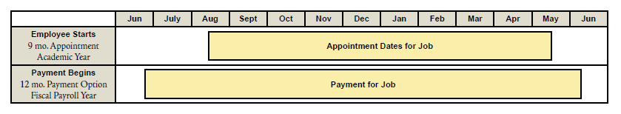

Example of overpayment: The faculty member’s appointment will terminate on 11/XX/XX (end of the 11th pay period). According to both the employee’s offer letter and Job Data, the base salary for this employee is $35,000. Using the example calculations below, determine what the employee was actually paid against what is owed to the employee based on the actual dates of the appointment. Follow the formula to determine the underpayment or overpayment. 